**CS5250 Advanced Operating Systems**

**Pop Quiz 9**

Name: _______________Ding Fan_________________________

Student Number: ________A0248373X_____________________

Given the following Linux radix tree, what are the indexes of the three pages (in base 10)?

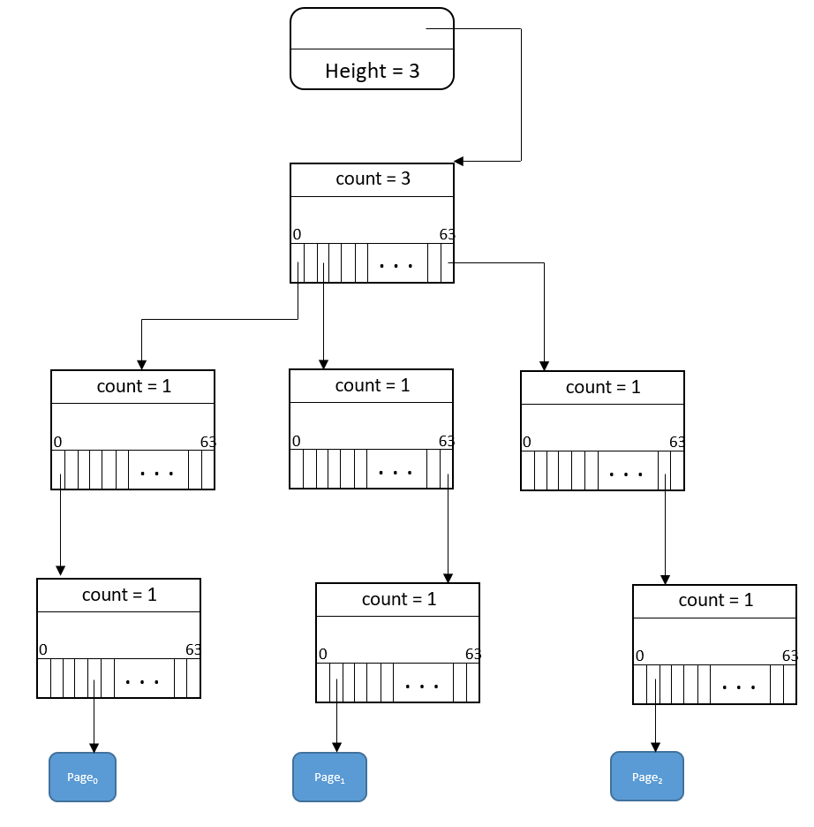

* Page0: 5-1=4
* Page1: 64*64*2 + 64*63 +2 -1=12225
* Page2: 64*64*63 + 64*62 +2 -1 =262017